


Computer Communications 26 (2003) 388–403

Invited Paper

www.elsevier.com/locate/comcom

A new trafﬁc engineering manager for DiffServ/MPLS networks:
design and implementation on an IP QoS Testbed

I.F. Akyildiz^{a,}*, T. Anjalia, L. Chenª, J.C. de Oliveiraª, C. Scoglioª,
A. Sciuto^{b}, J.A. Smith^{b}, G. Uhl^{b}
aBroadband and Wireless Networking Lab, School of Electrical and Computer Engineering, Georgia Institute of Technology, Atlanta, GA 30332, USA
bNASA Goddard Space Flight Center, Greenbelt, MD 20771, USA
Received 12 May 2002; accepted 14 May 2002

Abstract
In a multi-service network, different applications have varying QoS requirements. The IETF has proposed the DiffServ architecture as a
scalable solution to provide Quality of Service (QoS) in IP Networks. In order to provide quantitative guarantees and optimization of
transmission resources, DiffServ mechanisms should be complemented with efﬁcient trafﬁc engineering (TE) mechanisms, which operate on
an aggregate basis across all classes of service. The MultiProtocol Label Switching (MPLS) technology is a suitable method to provide TE,
independent of the underlying layer2 technology. Currently, the combined use of Differentiated Services (DiffServ) and MPLS is a promising
technique to provide Quality of Service (QoS), while efﬁciently exploiting network resources. In this paper, TEAM, an automated manager
for DiffServ/MPLS networks is introduced and its design. The design and implementation details are discussed.
q 2002 Elsevier Science B.V. All rights reserved.
Keywords: DiffServ; MultiProtocol Label Switching; Trafﬁc Engineering; Automated Network Management; Testbed

1. Introduction

One of the most actively studied open issues in several
areas of communication networks is the problem of
bandwidth reservation and management. Load balancing is
another important issue. It is desirable to avoid portions of
the network becoming over-utilized and congested, while
alternate feasible paths remain underutilized. These issues
are addressed by Trafﬁc Engineering (TE). The Multi-
Protocol Label Switching (MPLS) technology is a suitable
method to provide TE, independent of the underlying layer2
technology [1,2]. MPLS per se cannot provide service
differentiation, which brings up the need to complement it
with another technology capable of providing such feature:
DiffServ. DiffServ is becoming prominent in providing
scalable network designs supporting multiple classes of
services. When optimization of resources is sought,
DiffServ mechanisms need to be complemented by existing

* Corresponding author. Tel.: ю1-404-894-5141; fax: ю1-404-894-7883.
E-mail addresses: ian@ece.gatech.edu (I.F. Akyildiz), tricha@ece.
gatech.edu (T. Anjali), leochen@ece.gatech.edu (L. Chen), jau@ece.
gatech.edu (J.C. de Oliveira), caterina@ece.gatech.edu (C. Scoglio),
asciuto@rattler-e.gsfc.nasa.gov (T. Sciuto), jsmith@rattler-e.gsfc.nasa.
gov (J.A. Smith), uhl@rattler-e.gsfc.nasa.gov (G. Uhl).

MPLS trafﬁc engineering mechanisms, which then becomes
DiffServ-aware Trafﬁc Engineering (DS-TE) [3], currently
under discussion in Internet Engineering Task Force (IETF).
In this case, DiffServ and MPLS both provide their
respective beneﬁts. It is obvious that such future networks
cannot be managed manually when all new protocols are
implemented. Therefore, automated managers need to be
developed to simplify network management and to engineer
trafﬁc efﬁciently [4].
With the objective to studying and researching the issues
mentioned above, we assembled an IP QoS testbed in our
laboratory (http://www.ece.gatech.edu/research/labs/bwn).
The testbed is a high-speed top-of-the-line mix of highly
capable routers and switches for testing DiffServ and MPLS
functionalities. During our experiences with the testbed, we
realized the need for an improved set of algorithms for
network management and also an integrated architecture for
an automated network manager. This led to the design and
implementation of Trafﬁc Engineering Automated Manager
(TEAM).
Individual problems addressed by TEAM may already
have been considered, but to the best of our knowledge, an
integrated solution does not exist. We are developing
TEAM as a centralized authority for managing a

0140-3664/03/$ - see front matter q 2002 Elsevier Science B.V. All rights reserved.
PII: S 0 1 4 0 - 3 6 6 4 ( 0 2 ) 0 0 1 5 7 - 3

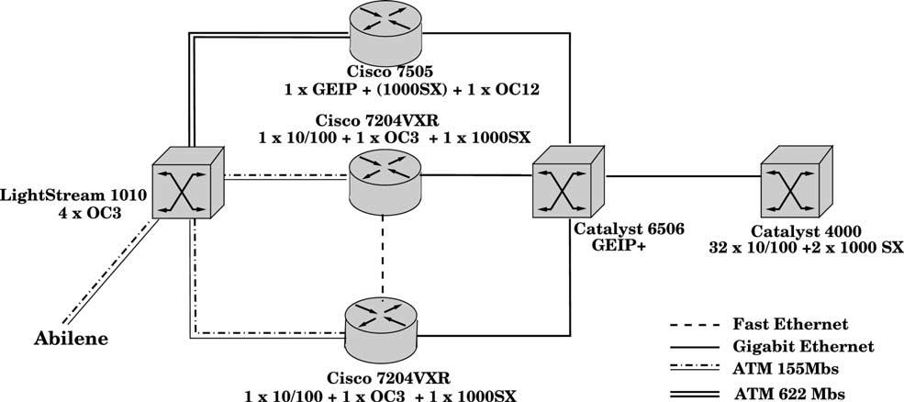
I.F. Akyildiz et al. / Computer Communications 26 (2003) 388–403

Fig. 1. BWN-Lab IP QoS Testbed.

389

DiffServ/MPLS domain. Our proposal is a comprehensive
study that describes practical solutions for MPLS network
management. TEAM is responsible for dynamic bandwidth
and route management. Based on the network state, TEAM
takes the appropriate decisions and reconﬁgures the network
accordingly. TEAM is designed to provide a novel and
unique architecture capable of managing large scale
MPLS/DiffServ networks.
The structure of the rest of the paper is as follows. In
Section 2, we enlist the components of our IP QoS testbed.
The following section, Section 3, includes a design
description of TEAM along with comparison with other
MPLS network management tools. In Section 4 we present
our proposed algorithms for bandwidth management,
namely Label Switched Path (LSP) setup and dimensioning,
LSP preemption and LSP capacity allocation. Section 5
discusses the route management aspects of TEAM, followed
by the description of the measurement tool employed by
TEAM in Section 6. In Section 7, we present the
implementation details for TEAM. Finally, we conclude
the paper in Section 8.

2. Physical testbed

We have a full-ﬂedged Next Generation Internet routers
physical testbed in our Broadband and Wireless Networking
Laboratory (BWN-Lab) at Georgia Institute of Technology,
equipped with DiffServ capable routers and switches
manufactured by Cisco. We have a Cisco 7500 router with
a Gigabit Ethernet card and a layer 3 switch Catalyst 6500
with an enhanced Gigabit Ethernet card and also other
routers and switches. These routers and switches are widely
deployed in the backbones of current high-speed networks.
All our routers support MPLS and a variety of QoS
technologies such as RSVP and DiffServ. Currently all
devices have SNMP enabled and different measurement
tools like MRTG and Netﬂow are being evaluated. During
the analysis of MRTG, a new improved version of the tool
was developed by our group: MRTGю ю (described in
Section 6). It allows managers to monitor trafﬁc with up to
10 s interval, rather than the original 5 min sampling of
MRTG, providing ﬁne-grained detail about the state of the
network. Our testbed is connected via an OC3 link to
Abilene, the advanced backbone network of Internet2
society, that supports development and deployment of
new applications. We perform end-to-end QoS performance
experiments with NASA Goddard in Maryland and NASA
Ames in California. The objective of the experiments is to
study the advantages and disadvantages of using DiffServ in
a heterogeneous trafﬁc environment. The trafﬁc under study
is generated from voice, video and data sources. Fig. 1
shows a schematic of our testbed assembly. Next, we
present a brief description of the experiments we performed.

2.1. DiffServ experiments

We validated the use of ALTQ and CAR as the
scheduling and policing mechanisms, respectively, for
providing DiffServ [5]. Furthermore, we investigated the
use of Class-Based Weighted Fair Queueing (CBWFQ) as
another scheduling mechanism, as explained next. Four
UDP ﬂows are separated into four different DiffServ PHBs
and CBWFQ applied at the intermediate hops according to
Fig. 2(a). In Fig. 2(b), we show the result of the experiments
and the efﬁciency of the operation of CBWFQ. In the case of
no congestion, the ﬂows get the desired bandwidth. In case
of congestion, the ﬂow throughputs are reduced to fairly
share the link according to the minimum guarantees
provided by CBWFQ. With these experiments, we con-
cluded that DiffServ is a suitable technology for providing
QoS on an aggregated basis. DiffServ can be enhanced with
the TE capabilities of MPLS to provide end-to-end QoS.

2.2. MPLS experiments

We conducted some experiments to show the efﬁciency
of TE provided by MPLS technology. Various TCP and
UDP ﬂows were sent from router 1 to router 2. In the
absence of TE, all the ﬂows chose the shortest path between

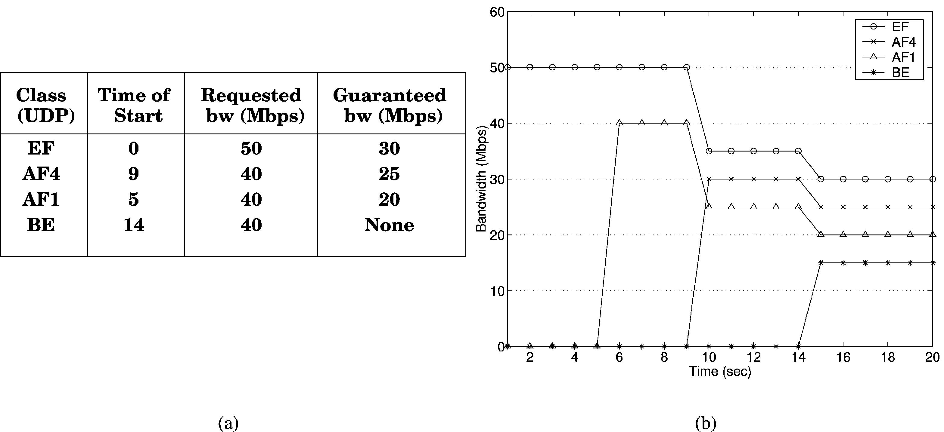
390

I.F. Akyildiz et al. / Computer Communications 26 (2003) 388–403

Fig. 2. DiffServ experiments.

the two routers, in effect starving the TCP ﬂows for
bandwidth. If LSPs are created between the two routers, but
TCP and UDP ﬂows are still forced to share bandwidth,
again TCP ﬂows starve. If the ﬂows are separated into
different LSPs by themselves, they do not interfere with
each other. For the example case shown in Fig. 3, the UDP
ﬂows of 40 Mbps are sharing Tunnel 1 whereas the TCP
ﬂows are occupying the Tunnels 2 and 3 individually.
Running experiments on our physical testbed, we
discovered shortcomings in some of the current DiffServ-
MPLS functionalities. In particular, the LSP setup is manual
with human intervention and no optimal decision policy
exists. The LSP preemption policy is based purely on
priority, which leads to bandwidth wastage. The LSP
capacity is manually set to the sevice level agreement values
plus a small cushion for bandwidth guarantee. This leads to
bandwidth wastage. Also LSPs can be routed explicitly, thus
creating the need for a policy to optimize the routing. Based
on these revelations, we investigated and proposed solutions
to each of these issues [6 – 11]. Furthermore, there exists a
need to obtain a balance between the objectives of efﬁcient
resource utilization and efﬁcient QoS provisioning. A
manager entity for the whole domain is best-suited to
provide such a balance. Therefore, we realized the potential
for an integrated automated MPLS network manager and
proposed TEAM.

3. Team Trafﬁc Engineering automated Manager

The design and management of an MPLS network is a
fundamental key to the success of the QoS provisioning.
Many problems need to be solved such as LSP dimension-
ing, set-up/tear-down procedures, routing, adaptation to
actual carried trafﬁc, preemption, initial deﬁnition of the
network topology, etc. To illustrate the inter-relations of the
listed problems for MPLS network management, let us
consider the scenario where network planning methods have
provided an initial topology of the MPLS networks which
needs to be adapted to the changing trafﬁc demands.
Possible events could be arrival of a request for LSP setup
based on the SLS agreements or arrival of a bandwidth
request in the MPLS network. The ﬁrst event can be handled
by the combined use of three of our proposed methods in the
order: LSP routing, LSP preemption, and LSP capacity
allocation. The LSP routing aims to ﬁnd the route on the
physical network over which the LSP will be routed. LSP
preemption decides if any existing LSPs can be preempted
on the route to make way for the new LSP if there is not
enough available bandwidth. LSP capacity allocation
method tries to ﬁne-tune the LSP capacity allocation to
avoid unused reserved bandwidth. The second event of
arrival of a bandwidth request triggers the LSP setup and
dimensioning which may in turn trigger the LSP creation
steps of routing, preemption and capacity allocation.
The above-mentioned problems can be handled at two
different time scales, namely short-term and long-term.
Short-term Network Management (minutes, hours) is based
on the current state of the network. Dynamic methods for re-
dimensioning and routing are designed to provide efﬁcient
resource utilization and load balance for MPLS networks.
These methods perform real-time adaptation to the actual
network state (Bandwidth and Route Management). Long-
term Network Management (months, years) is used to
provide an initial design and dimension of the network
topology based on the predicted utilization of the network.
TEAM performs both short-term and long-term manage-
ment. In the following sections, we present the various
approaches developed by us for short-term management.
Several TE servers have been already proposed in
literature. The RATES server [12] is a software system
developed at Bell Laboratories for MPLS trafﬁc engineering
and is built using centralized paradigm. RATES communicate
only with the source of the route and spawns off signaling from
the source to the destination for route setup. RATES views this
communication as a policy decision and therefore uses
Common Open Policy Service (COPS) [13] protocol.
RATES uses a relational database as its information store.

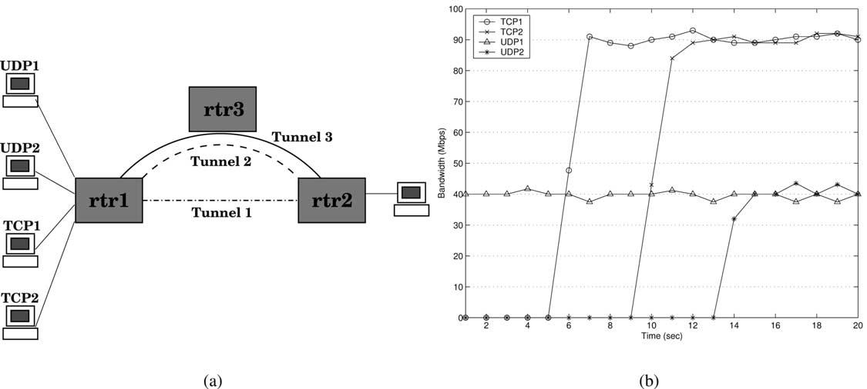
I.F. Akyildiz et al. / Computer Communications 26 (2003) 388–403

Fig. 3. MPLS experiment setup and results.

391

RATES implements Minimum Interference Routing Algor-
ithm (MIRA) [14], based on the concept of minimum
interference, to route LSPs. It consists of the following
major modules: explicit route computation, COPS server,
network topology and state discovery, dispatcher, GUI, an
open Application Programming Interface, data repository, and
a message bus connecting these modules. Summarizing,
RATES is a well-designed TE tool, but TE is only performed
by the routing of bandwidth guaranteed LSPs.
Another state dependent TE mechanism to distribute
network load adaptively is suggested in Ref. [15]. MATE
assumes that several explicit LSPs have been established
between an ingress and egress node in an MPLS domain using
a standard protocol like RSVP-TE. The goal of the ingress
node is to distribute the trafﬁc across the LSPs. It is important
to note that MATE is intended for trafﬁc that does not require
bandwidth reservation, with best-effort trafﬁc being the most
dominant type. Since the efﬁcacy of any state-dependent TE
scheme depends crucially on the trafﬁc measurement process,
MATE requires only the ingress and the egress nodes to
participate in the measurement process. Based on the authors’
experience, available bandwidth was considered difﬁcult to be
measured, so packet delay and loss have been selected for
measurement purposes. The network scenario for which
MATE is suitable is when only a few ingress-egress pair are
considered. In fact for a network with N nodes, having x LSPs
between each pair of nodes, the total number of LSP is in the
order ofxN²which can be a large number. Furthermore it is not
designed for bandwidth guaranteed services.
TEQUILA [16] is a European collaborative research
project looking at an integrated architecture and associated
techniques for providing end-to-end QoS in a DiffServ-based
Internet. In TEQUILA, a framework for Service Level
Speciﬁcation has been produced, an integrated management
and control architecture has been designed and currently
MPLS and IP-based techniques are under investigation for TE.
The TEQUILA architecture includes control, data and
management planes. The management plane aspects are

related to the concept of Bandwidth Broker (BB) and each
Autonomous System should deploy its own BB. The BB
includes components for monitoring, TE, SLS management
and policy management. The TE subsystem is further
decomposed into modules of trafﬁc forecast, network
dimensioning, dynamic route management, and dynamic
resource management. The MPLS network dimensioning is
based on the hose model which is associated with one ingress
and more than one egress node. The dynamic route manage-
ment module considers: (a) setting up the forwarding
parameters at the ingress node so that the incoming trafﬁc is
routed to LSPs according to the bandwidth determined by
network dimensioning, (b) modifying the routing according to
feedback received from network monitoring and (c) issuing
alarm to network dimensioning in case available capacity
cannot be found to accommodate new connection requests.
The dynamic resource module aims at ensuring that link
capacity is fairly distributed among the trafﬁc classes sharing a
link, by appropriately setting buffer and scheduling par-
ameters. TEQUILA architecture is very interesting and shows
a similar approach for MPLS networks design and manage-
ment compared to TEAM. However, the algorithms and
techniques to be implemented in TEQUILA are not deﬁned in
detail at the moment, and their quantitative evaluation has not
been carried out.
The use of MPLS for TE, quality of service and virtual
private networks has been decided at GlobalCenter [17], one
of the 10 largest ISPs in the USA. Approximately 200
routers participate in the MPLS system. Since a full meshed
network would result in an MPLS system of about 40,000
LSPs, it is decided to deploy a hierarchical MPLS system of
two layers of LSPs. To deploy an MPLS system for TE, the
following procedure is proposed based on the network
operator experience: (a) Statistics collection for trafﬁc
utilizing LSPs, (b) LSP deployment with bandwidth
constraints, (c) Periodic update of LSP bandwidth and (d)
Off-line constraint based routing. To provide QoS, MPLS is
used in combination with the DiffServ architecture. Since it

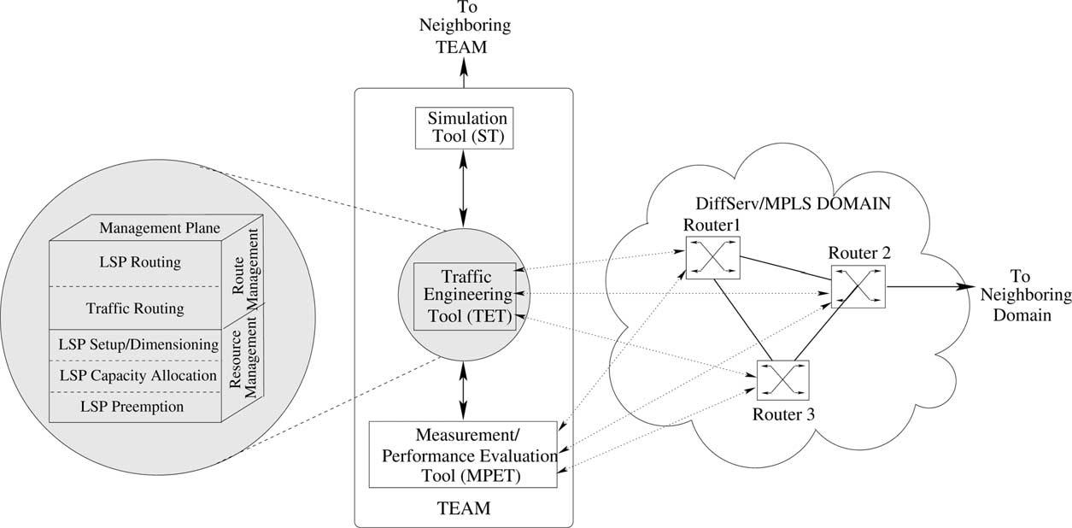
392

I.F. Akyildiz et al. / Computer Communications 26 (2003) 388–403

Fig. 4. TEAM: trafﬁc engineering automated manager.

is desirable to use different LSPs for different classes, the
physical network is divided into multiple virtual networks,
one per class. These networks can have different topology
and resources. The end effect is that premium trafﬁc can use
more resources. Many tools are needed for designing and
managing these virtual networks. The use of MPLS for TE
and QoS decided by an important ISP is the conﬁrmation
that MPLS is a very promising technique even from a
business point of view. The solution provided by TEAM is
in line with the QoS architecture deﬁned by GlobalCenter.
The architecture of our TEAM is shown in Fig. 4. As shown,
TEAM will have a central server, the Trafﬁc Engineering Tool
(TET), that will be supported by two tools: Simulation
Tool (ST) and Measurement/Performance Evaluation Tool
(MPET). The TET and the MPET will interact with the routers
and switches in the domain. The MPET will provide a measure
of the various parameters of the network and routers like the
available bandwidth, overall delay, jitter, queue lengths,
number of packets dropped in the routers, etc. This information
will be input to the TET. Based on this measured state of the
network, the TET decides the course of action, such as to vary
the capacity allocated to a given LSP or to preempt a low
priority LSP to accommodate a new one, or to establish the path
for a trafﬁc requiring a speciﬁed QoS. The TET also will
automatically implement the action, conﬁguring accordingly
the routers and switches in the domain. Whenever required, the
TET can consolidate the decision using the ST. The ST will
simulate a network with the current state of the managed
network and apply the decision of the TET to verify the
achieved performance. The TET management tasks include
Bandwidth Management (LSP setup/dimensioning, LSP pre-
emption, LSP capacity allocation) and Route Management
(LSP routing), as shown in Fig. 4. In the following sections, we
provide details of our already proposed and implemented
algorithms.

The prototype of TEAM is being implemented on our
Testbed. The TEAM protocol stack will reside on an end-
host. MPET and TET will interact with the routers and
switches of the domain controlled by the TEAM. The
interfaces to the routers will be based on Simple Network
Management Protocol (SNMP), Common Open Policy
Service Protocol for Provisioning (COPS-PR), and Com-
mand-Line Interfaces (CLI). SNMP is an open-source
protocol to retrieve the Management Information Bases
(MIBs) and COPS-PR for Policy Information Bases (PIBs)
from the routers. They can also make router conﬁguration
changes. To ensure security, we will use SNMPv3. MPET is
currently based on MRTGю ю, our enhanced version of
MRTG, and retrieves trafﬁc rate information on every
interface with up to 10 s interval.

4. Bandwidth management

Bandwidth management deals with managing the
resources of an MPLS network in an efﬁcient manner to
meet QoS requirements. It comprises of LSP setup and
dimensioning (Section 4.1), preemption (Section 4.2), and
capacity allocation (Section 4.3). In the event of an LSP
setup request, the LSP preemption and capacity allocation
functions are invoked. In the case of bandwidth reservation
request, LSP setup and dimensioning procedures are
triggered which may in turn initiate the LSP creation steps
of routing, preemption and capacity allocation.

4.1. LSP setup and dimensioning

An important aspect in designing an MPLS network is to
determine an initial topology and to adapt it to the trafﬁc

I.F. Akyildiz et al. / Computer Communications 26 (2003) 388–403

393

load. A topology change in an MPLS network occurs when a
new LSP is created between two nodes. The LSP creation
involves determining the route of the LSP and the according
resource allocation to the path. A fully connected MPLS
network can be used to minimize the signaling. The
objective of our algorithm is to determine when an LSP
should be created and how often it should be re-
dimensioned.

4.1.1. Related work
Two different approaches, trafﬁc-driven and topology-
driven [1], can be used for MPLS network design. In the
trafﬁc-driven approach, the LSP is established on demand
according to a request for a ﬂow, trafﬁc trunk or bandwidth
reservation. The LSP is released when the request becomes
inactive. In the topology-driven approach, the LSP is
established in advance according to the routing protocol
information, e.g. when a routing entry is generated by
the routing protocol. The LSP is maintained as long as the
corresponding routing entry exists, and released when the
routing entry is deleted. The advantage of the trafﬁc-driven
approach is that only required LSPs are set-up; while in the
topology-driven approach, the LSPs are established in
advance even if no data ﬂow occurs.
A simple LSP set-up policy based on the trafﬁc-driven
approach has been proposed in Ref. [18], in which an LSP is
established whenever the number of bytes forwarded within
1 min exceeds a threshold. This policy reduces the number

The network design scheme in Ref. [20], utilizes an
online recursive estimation of effective bandwidths for
bandwidth allocation and buffer dimensioning under QoS
requirements on queuing delay and packet loss probability.
The scheme can be extended for MPLS networks but the
authors have performed trafﬁc demand estimation for each
source destination pair based on inverse Erlang-B formula
followed by optimal allocation algorithm for the estimation.
This may not be true for the Internet trafﬁc in general.
Class-level and path-level aggregation based network
designs for statistical end-to-end delay guarantees are
presented and compared in Ref. [21]. The authors have
shown that the class-level aggregation results in a better
statistical multiplexing gain because path-level aggregation
for a fully meshed path network is viable only for small
networks. In our approach, we will show that even path-
level aggregation is beneﬁcial for large networks if they are
not fully meshed.

4.1.2. Optimal and sub-optimal solution
Our proposed optimal and sub-optimal decision policies
[7] for LSP set-up are based on continuous-time Markov
Decision Process (MDP) [22] theory. The cost functions for
the MDP theory have been deﬁned in Ref. [7]. Following the
theory of MDPs, we deﬁne the expected inﬁnite-horizon
discounted total cost, v^{p}рS₀Ю; with discounting rate a; given
that the process occupies state S₀at the ﬁrst decision instant
and the decision policy is p by:

of LSPs in the network; however, it has very high signaling
costs and needs high control efforts for variable and bursty
trafﬁc as in the case of a fully connected network.
A threshold-based policy for LSP set-up is suggested in

v^{p}a^{р}S₀Ю ј E_{S}p₀
( X₁

mј0

e²at_{m}
"

Wsign^{р}S_{m}; aЮ

#)

Ref. [6]. It provides an on-line design for MPLS network
depending on the current trafﬁc load. The proposed policy
is a trafﬁc-driven approach and balances the signaling and
ю
рt_{m}ю1
t_{m}
e²aрt2t_{m}Ю_{Ѕ}w_{b}рS_{m}; aЮ ю w_{sw}рS_{m}; aЮdt
: р1Ю

switching costs. By increasing the number of LSPs in a
network, the signaling costs increase while the switching
costs decrease. In the policy, LSPs are set-up or torn-down
depending on the actual trafﬁc demand. Furthermore, since
a given trafﬁc load may change depending on time, the
policy also performs ﬁltering in order to avoid oscil-
lations, which may occur in case of variable trafﬁc. The
policy is ‘greedy’ in the sense that it tries to minimize
instantaneous costs, rather than trying to ﬁnd the optimal
solution.
An approach to setup inter-domain LSPs is given in
Ref. [19]. In order to connect LSPs in different domains,
the use of specialized bandwidth broker agent called
Bandwidth Management Point (BMP) is proposed. The
architecture and the signaling protocols to establish inter-
domain LSPs and distribute inter-domain labels are
presented. The approach assumes that the decision for
where t₀; t₁; … represent the times of successive instants
when events occur and Wsign^{р}S_{m}; aЮ represents the ﬁxed part
of the cost incurred whereas Ѕw_{b}рS_{m}; aЮ ю w_{sw}рS_{m}; aЮ
represents the continuous part of the cost between times
t_{m}and t_{m}ю1:
The optimization objective is to ﬁnd a policy p^{p}such
that:
p
v^{p}
a^{р}sЮ ј inf v^{p}a^{р}sЮ:
p[P
The optimal decision policy can be found by solving the
optimality equations for each initial state S. We assume that
the bandwidth requests arrive according to a Poisson
process with rate l and the request durations are
exponentially distributed with rate m: With our assumptions
of a discounted inﬁnite-horizon CTMDP, the optimality
equations can be written as:

LSP setup has already been made based on the nominal
capacity allocation from the SLS agreements. It does not
perform decisions about the need for the LSP and whether

vрSЮ ј min
8
<
rрS; aЮ ю

l ю m

X
9
=
qрjlS; aЮvрjЮ

р2Ю

it is cost-effective.
a[A :
l ю m ю a
j[S
;

394

I.F. Akyildiz et al. / Computer Communications 26 (2003) 388–403

where rрS; aЮ is the expected discounted cost between two
decision instants and qрjlS; aЮ is the probability that the
system occupies state j at the subsequent decision instant,
given that the system is in state S at the earlier decision
instant and action a is chosen.
Some assumptions have been made in the approach. The
ﬁrst assumption concerns the capacity of the underlying
physical links. It is assumed that there is always enough
capacity, which can be reserved by the overlaid LSPs. The
second assumption is about the routing algorithm in use for
the LSPs and for the bandwidth requests. It is assumed that
the LSPs are always routed along the min-hop path between
the ingress and egress nodes. Furthermore, the bandwidth
requests are routed either on the direct LSP or on the
multiple-LSP path overlaying the min-hop path. These
assumptions imply that the analysis holds for any node pair
independent of trafﬁc for other node pairs.
The optimal policy is derived by the solution of the
optimality Eq. (2) for each initial state. The optimal policy
p^{p}has a control-theoretic structure and it is stationary
implying same decision rule at each decision instant. The
threshold structure of the optimal policy facilitates the
solution of the optimality Eq. (2) but still it is difﬁcult to pre-
calculate and store the solution because of the large number
of possible system states. So, we propose a sub-optimal
policy, called the Least One-Step Cost Policy, that is easy
and fast to calculate.
The proposed Least One-Step Cost policy is an
approximation to the solution of the optimality Eq. (2). It
minimizes the cost incurred between two decision instants.
Instead of going through all the iterations of the value
iteration algorithm, we perform only the ﬁrst iteration. The
one-step optimal policy p#is also control-theoretic in
structure and stationary implying same decision rule at each
decision instant.

4.2. LSP preemption

In IETF RFC 2702, [1], issues and requirements for TE in
an MPLS network are highlighted. In order to address both
trafﬁc oriented and resource oriented performance objec-
tives, the authors point out the need for priority and
preemption parameters as TE attributes of trafﬁc trunks. A
trafﬁc trunk is an aggregate of trafﬁc ﬂows belonging to the
same class. Trafﬁc trunks are routable objects, distinct from
the LSP which they traverse, and are unidirectional. A
request for resources for a new trafﬁc trunk implies the setup
of a new LSP.
The preemption attribute determines whether an LSP
with a certain priority attribute can preempt another LSP
with a lower priority attribute from a given path, when there
is a competition for available resources. The preempted LSP
may then be rerouted. Preemption can be used to assure that
high priority LSPs can be always routed through relatively
favorable paths in a differentiated services environment. In
the same context, preemption can be used to implement

various prioritized access policies as well as restoration
policies following fault events [1].

4.2.1. Related work
Although not a mandatory attribute in the traditional IP
world, preemption becomes indeed a more attractive
strategy in a differentiated services scenario [23,24].
Moreover, in the emerging optical network architectures,
preemption policies can be used to reduce restoration time
for high priority trafﬁc trunks under fault conditions.
Nevertheless, in the DiffServ-aware Trafﬁc Engineering
(DS-TE) approach, whose issues and requirements are
discussed in Ref. [3], the preemption policy is again
considered an important piece on the bandwidth reservation
and management puzzle, but no preemption strategy is
deﬁned.
Running preemption experiments using commercial
routers, we could conclude that the preempted LSPs were
always the ones with the lowest priority, even when the
bandwidth allocated was much larger than the one required
for the new LSP. This policy would result in high bandwidth
wastage for cases in which rerouting is not allowed. An LSP
with a large bandwidth share would be preempted to give
room to a higher priority LSP that requires a much lower
bandwidth.
A new LSP setup request has two important parameters:
bandwidth and preemption level. In order to minimize
wastage, the set of LSPs to be preempted can be selected by
optimizing an objective function that represents these two
parameters, and the number of LSPs to be preempted. More
speciﬁcally, the objective function could be any or a
combination of the following [23 – 25]:

1. Preempt the connections that have the least priority
(preemption level). The QoS of high priority trafﬁcs
would be better satisﬁed.
2. Preempt the least number of LSPs. The number of LSPs
that need to be rerouted would be lower.
3. Preempt the least amount of bandwidth that still
satisﬁes the request. Resource utilization would be
better.

In Ref. [25], the authors propose connection preemption
policies that optimize the discussed criteria in a given order
of importance: number of connections, bandwidth, and
priority; and bandwidth, priority, and number of connec-
tions. The novelty in our approach, [8], is to propose an
objective function that can be adjusted by the service
provider in order to stress the desired criteria. No particular
criteria order is enforced. Moreover, our preemption policy
is complemented by an adaptive rate scheme. The resulting
policy reduces the number of preempted LSPs by adjusting
the rate of selected low-priority LSPs that can afford to have
their rate reduced in order to accommodate a higher-priority
request. This approach minimizes service disruption and
rerouting decision and signaling.

I.F. Akyildiz et al. / Computer Communications 26 (2003) 388–403

395

4.2.2. Proposed new preemption policy: optimal solution
and heuristic
Consider a request for a new LSP setup with bandwidth b
and a certain preemption level. When preemption is needed,
due to insufﬁcient available resources, the preemptable
LSPs will be chosen among the ones with lower preemption
level in order to ﬁt r (the difference between the requested
bandwidth b and the available bandwidth on a given link).
Without loss of generality, we assume that bandwidth is
available in bandwidth modules, which implies that
variables such as r and b are integers.
Using an integer optimization formulation to implement
our preemption policy, [8], we minimize the following
objective function:

F ј aрpriority of preempted LSPsЮ

ю bрnumber of preempted LSPsЮ

ю gрtotal preempted capacityЮ р3Ю
where the coefﬁcients a; b; and g are suitable weights that
can be conﬁgured by the network operator in order to stress
the desired importance of each component in F. As a
constraint, we must ensure that the preempted LSPs release
enough bandwidth to satisfy the new request.
Our proposed formulation, [8], allows the balance of the
three important criteria, and does not imply any order of
importance. The network operator is free to adjust the

Some applications such as non-real-time video or data
transfer can afford to have their transmission rate reduced,
and would be the most likely to be assigned to such Class-
Types and preemption levels. By reducing the rate in a fair
fashion, the LSPs would not be torn down, there would not
be service disruption, extra setup and torn down signaling,
or rerouting decisions. For the DiffServ technology, trafﬁc
aggregates assigned to the Assured Forward Per-Hop
Behavior (AF PHB) would be the natural candidates for
rate reduction. Whereas Expedited Forward Per-Hop
Behavior (EF PHB) supports services with ‘hard’ bandwidth
and jitter guarantees, the AF PHB allows for more ﬂexible
and dynamic sharing of network resources, supporting the
‘soft’ bandwidth and loss guarantees appropriated for bursty
trafﬁc [27].
Similarly to the preemption policy, we formulate the
adaptive preemption policy as an integer optimization
problem, [8]. We assume that bandwidth is available in
bandwidth modules, and choose a set of LSPs, which can
afford to have their rate reduced.
We propose the following new objective function F:

F ј aрpriority of preemted bandwidth modulesЮ

ю bрnumber ofpreempted LSPsЮ

ю gрtotal preempted capacityЮ

coefﬁcients according to the best interest of each particular
network. However, improvements regarding computational
issues can be done.
ю bandwidth module cost per LSP
р4Ю

The choice of LSPs to be preempted is known to be an
NP-complete problem [26]. For networks of small and
medium size, or for a small number of LSPs, the online use
of an optimization method is a fast and accurate way to ﬁnd
the solution. However, for large networks and large number
of LSPs, a simple heuristic that could approximate the
optimal result would be preferable. In order to simplify the
online choice of LSPs to be preempted, we propose an
heuristic, [8], in which a ‘cost function’ is calculated for
each LSP, and the ones with smaller cost that add enough
bandwidth to accommodate r are chosen to be preempted.

4.2.3. New preemption policy with adaptive rate scheme:
optimal adaptive solution and heuristic
In Section 4.2.2, when a set of LSPs was chosen to be
preempted, those LSPs were torn down and could be
rerouted, which implied extra signaling and routing
decisions. In order to avoid or minimize rerouting, we
propose to reduce the number of preempted LSPs by
selecting a few low-priority LSPs that would have their rate
reduced by a certain maximum percentage in order to
accommodate the new request. In the future, whenever there
exists available bandwidth in the network, the lowered-rate
LSPs would fairly increase their rate to the original reserved
bandwidth.
In this equation, the bandwidth module cost per LSP is
proportional to the number of modules reserved by the LSP.
Coefﬁcients a; b; and g are used for the same purpose as
previously: in order to stress the importance of each
component in F.
As for constraints, we must make sure that the bandwidth
requirement is met, that all the bandwidth modules from an
LSP are made available when that LSP is preempted, that
the respective modules for the LSPs that will reduce their
rate are also preempted, and that the preempted rate will not
be more than D% of the reserved bandwidth for that LSP.
We propose to use an heuristic for the adaptive policy in
order to simplify and expedite the online choice of LSPs that
will have their rate reduced or will be completely
preempted. The cost function (calculated individually for
each LSP) for this heuristic is composed by terms
representing the cost of preempting an LSP, the choice of
minimum number of LSPs for preemption or rate-reduction,
the amount of bandwidth to be preempted, and an additional
cost by preempted bandwidth module, similar to the one in
F. This additional cost is calculated as the inverse of the
amount of bandwidth reserved by the considered LSP. In
this way, an LSP with more bandwidth modules will be
more likely to have its rate reduced than one with just a few
number of modules.

396

4.3. LSP capacity allocation

I.F. Akyildiz et al. / Computer Communications 26 (2003) 388–403

increasingly signiﬁcant once the bandwidth requirements
of the users become considerable.

In the LSP setup and dimensioning area of bandwidth
management, the LSPs are dimensioned based on the
nominal requirements derived from the SLS agreements. In
reality, these nominal speciﬁcations may not be enough or
too elaborate or too conservative. So, there is a need for a
scheme for capacity allocation for LSPs, which is based on
some measurements of the actual trafﬁc carried on the LSP.
Conventional approaches to resource allocation on a link
rely on predetermined trafﬁc characteristics which may be
difﬁcult to predict. Network trafﬁc can be divided into
elastic (e.g. TCP) and non-elastic (e.g. UDP) trafﬁc [28].
These two types differ in their requirements from the
network. Packet level characteristics of elastic trafﬁc are
controlled by the transport protocol and its interactions with
the network whereas the non-elastic ﬂows have inherent rate
characteristics that must be preserved in the network to
avoid losses. This implies that the source characteristics
may not be known ahead of time, speciﬁed parameters may
not characterize the source adequately or a large number of
parameters may be required to deﬁne trafﬁc characteristics.
Current capacity allocation methods can be either off-line
or on-line. Off-line, or static, methods determine the
allocation amount before the transmission begins. These
approaches [29] are simple and predictable but lead to
resource wastage. On-line, or dynamic, methods [30 – 32]
periodically renegotiate resource allocation based on
predicted/measured trafﬁc behavior. These methods
undergo a large number of re-negotiations to satisfy the
QoS.
The capacity allocation scheme for LSPs can be extended
to be used for Bandwidth Brokers [33] in a DiffServ domain.
The scheme can be utilized to determine the capacity
allocation for an inter-domain link.

4.3.1. Related work
There are various approaches that can be employed to
obtain the capacity allocation for a link. The simplest ones
include prediction based on Gaussian assumption (from the
central limit theorem) and the Autobandwidth Allocator for
MPLS from Cisco [34]. The Gaussian assumption may not
hold for Internet trafﬁc in general. The autobandwidth
allocator decides the allocation with a phase lag, i.e. the
allocation during a time interval is based upon the maximum
trafﬁc during the previous interval. This can lead to
inefﬁcient allocation decisions. Another proposed scheme
for resource provisioning is to have a bandwidth ‘cushion’,
wherein extra bandwidth is reserved over the current usage.
As proposed in Ref. [35], if the trafﬁc volume on a link
exceeds a certain percentage of the agreement level, it leads
to a multiplicative increase in the agreement. A similar
strategy is proposed in case the trafﬁc load falls below a
considerable fraction of the reservation. This scheme
satisﬁes the scalability requirement but leads to an
inefﬁcient resource usage. This drawback can become
The goal of the allocation scheme should be not to derive
a near-perfect prediction, but to obtain an upper bound on
the resource requirement which is not too conservative. This
is because the resources on the links will be provisioned
based on the predicted values and if the prediction is near
perfect, it can lead to blocking of new requests or
degradation of service. With this aim in mind, the Minimum
Mean Square Error Linear Predictor in Ref. [30] cannot be
employed because it tries to predict the actual value of the
measured sequence.
There are currently several implementations of Band-
width Brokers underway. An architecture of a Bandwidth
Broker for scalable support of guaranteed services is given
in Ref. [36]. It considers mainly the admission control issues
for a Bandwidth Broker. A list of current bandwidth broker
implementations and their status is given on the Internet2
QBone Bandwidth Broker Advisory Council webpage [37].

4.3.2. Bandwidth estimation and forecast
We propose an on-line scheme called Estimation and
Prediction Algorithm for Bandwidth Brokers (EPABB), [9],
to estimate in an optimal manner, the amount of trafﬁc
utilizing an LSP based on a measurement of the instan-
taneous trafﬁc load. This estimate is then used to forecast the
trafﬁc bandwidth requests so that resources can be
provisioned on the LSP to satisfy the QoS of the requests.
The estimation is performed by the use of Kalman Filter
[38] theory while the prediction procedure is based on
deriving the transient probabilities of the possible system
states. This scheme would lead to reduction in the cushion
value without introducing per-ﬂow modiﬁcations in the
resource reservation. Kalman Filters have been previously
applied to ﬂow control in high-speed networks. In Ref. [39],
Kalman Filter was given for state estimation in a packet-pair
ﬂow control mechanism. In Ref. [40], Kalman Filter was
used to predict trafﬁc in a collection of VC sources in one
VP of an ATM network. Our work distinguishes itself from
previous work as the Kalman Filter is used as an optimal
estimation algorithm, instead of ﬁltering or smoothing and it
is an input to the capacity prediction step.
Consider an LSPр1; 2Ю between the Label Switched
Routers (LSRs). We estimate the utilization of the LSP
based on a periodic measurement of the aggregate trafﬁc on
LSPр1; 2Ю: We assume that the trafﬁc measurements are
performed at discrete time-points mT; m ј 1; 2; …; M for a
given value of T. The value of T is a measure of the
granularity of the estimation process. Larger values imply
less frequent estimation, which can result in larger
estimation errors. At the time instant m (corresponding to
mT ), the aggregate trafﬁc on LSPр1; 2Ю in the direction AS1
to AS2 is denoted by yрmЮ: We also assume that for the
duration р0; MT ; the number of established sessions that
use LSPр1; 2Ю is N. For each session, ﬂows are deﬁned as the
active periods. So, each session has a sequence of ﬂows

I.F. Akyildiz et al. / Computer Communications 26 (2003) 388–403

397

separated by periods of inactivity. We denote by xрmЮ the
number of ﬂows at the instant m and by xрmT ю tЮ; t [
р0; T the number of ﬂows in the time interval рmT; рm ю
1ЮT ; without notational conﬂict. Clearly, xрmЮ # N and is
not known/measurable. We also assume that each ﬂow has a
constant rate of b bits per second. So, nominally

explicit routing of LSPs enables the choice of non-shortest
paths to perform load balance and, therefore, TE in MPLS
networks [42]. A dynamic routing algorithm for LSP setup
is a must in this scenario, since off-line algorithms are not
suitable due to the necessary a priori knowledge of future
LSP setup requests.

yрmЮ ј bxрmЮ:
р5Ю

5.1.1. Related work

The underlying model for the ﬂows is assumed to be Poisson
with exponentially distributed inter-arrival times (parameter
l) and durations (parameter m). The analysis has been
carried out using this assumption and then our simulation
results show that, inspite of this assumption, the capacity
prediction is very close to the actual trafﬁc.
Our scheme [9] for resource allocation is split into two
steps. In the ﬁrst step, a rough measure of the aggregate
trafﬁc yрmЮ is taken and it is used to evaluate the number of
ﬂows through the Kalman Filter estimation process. In the
second step, we reserve the resources RрmЮ on the link
LSPр1; 2Ю for the time t [ рmT ; рm ю 1ЮT based on the
forecast of the evolution of xрmЮ:
We denote by p_{k}рtЮ; for t [ рmT ; рm ю 1ЮT the prob-
ability that the number of active ﬂows at time t is k, given
that the estimated number of active ﬂows at the previous
measurement instant was j. By using queuing theory [41],
we can write the differential equations for the probabilities,
solution of which will provide the matrices in the classical
Kalman ﬁlter formulation. The only measurable variable in
our system is yрmЮ: It is a measure, corrupted by noise, of the
aggregate trafﬁc on the link. Using yрmЮ we evaluate ^рmЮ;
an estimate of xрmЮ; using the Kalman ﬁlter setup as:

^рmЮ ј A^рm 2 1Ю ю B ю KрmЮЅyрmЮ 2 CA^рm 2 1Ю 2 CB
р6Ю
where KрmЮ is Kalman Filter gain. This gives an estimate of
the trafﬁc on the LSP. This estimate will be used to forecast
the trafﬁc for the purpose of resource reservation.
The optimal estimate ^рmЮ of the number of active ﬂows
can now be used to forecast Rрm ю 1Ю; the resource
requirement on the LSPр1; 2Ю:

5. Route management

Route management deals with deciding the routes for
LSPs over a physical network (Section 5.1) and for
bandwidth requests over an MPLS network. It is triggered
by the arrival of either an LSP setup request or a bandwidth
reservation requests in MPLS networks.

5.1. LSP routing

In MPLS networks, bandwidth guaranteed LSPs can be
used to provide QoS guarantees to customers in an IP
Virtual Private Network (VPN) fashion. The possibility of
Currently adopted routing schemes, such as OSPF [43]
and IS – IS [44], have the number of hops as the only metric
used for routing calculations, which may not be enough for
QoS routing purposes. In order to introduce QoS require-
ments in the routing process, the Widest-Shortest Path
(WSP) [45] and the Shortest-Widest Path (SWP) [46]
algorithms were proposed. In WSP, the shortest paths are
computed and the one with larger available bandwidth is
chosen to route the trafﬁc. In SWP, paths with the larger
available bandwidth are computed and, in case more than
one exists, the shortest one is selected. Modiﬁcations to
these routing algorithms have been proposed in order to
reduce complexity, such as the K shortest path, K widest-
shortest path, etc. which consider only K path options in
their decisions [47]. In Ref. [48], the authors discuss two
cost components of QoS routing: complexity and increased
routing protocol overhead. Improvements are suggested in
order to diminish these cost components, such as path pre-
computation and non-pruning triggering policies. Some of
these suggestions were used in our routing algorithm.
Finally, another QoS routing algorithm called MIRA [14]
tries to minimize the interference between different routes in
a network for a speciﬁc set of ingress – egress nodes. This
process involves the computation of maximum ﬂow values
for all ingress – egress pairs, computation of the so-called
critical links (links that are likely to suffer from inter-
ference), and the computation of weights to be used for a
weighted-shortest path algorithm that chooses the ﬁnal
route. Before running the weighted-shortest path algorithm,
links that have residual bandwidth smaller than the demand
are pruned. The shortcomings of MIRA include its
computation burden, uses longer paths than shortest-path
routing schemes, it is not able to estimate the interference
effects on clusters of nodes, and its is not very likely to be
implemented by vendors because of its complexity.

5.1.2. SPeCRA: Stochastic Performance Comparison
Routing Algorithm
For our algorithm, [10], we consider the problem of
setting up bandwidth guaranteed LSPs in an MPLS network,
where LSP setup requests arrive individually, and future
requests are not a priori known. We propose Stochastic
Performance Comparison Routing Algorithm (SPeCRA) to
solve the LSP routing problem in an MPLS network
characterized by heavy uncertainties of the offered trafﬁc.
Assume a LSP routing scheme (e.g. shortest-path) is
denoted by u: A set of possible LSP routing schemes (e.g.
shortest-path, K-shortest-path, shortest-widest-path, etc.)

398

I.F. Akyildiz et al. / Computer Communications 26 (2003) 388–403

will be denoted by Q: We will consider the percentage of
rejected LSP setup requests in an interval to be an estimate
of the probability of LSP setup rejection. This percentage
depends on the LSP routing scheme adopted and also on the
particular realization w of the stochastic process character-
izing the trafﬁc. In conclusion, the percentage of rejected
LSP setup requests from time 0 to t can be denoted by the
function f р0; t; u; wЮ:
We denote by p_{B}рu; tЮ the value assumed by the objective
function if the system would remain stationary after the time
t with the LSP routing scheme uрtЮ: Consider now a short
time interval Ѕt; t ю T ; which is contained in a steady
interval (namely, there exists an l such that t_{l}# t ,
рt ю TЮ , t_{l}ю1^{Ю}; during which no change is made in the LSP
routing scheme. An estimate of p_{B}рu; tЮ is given by the
fraction of LSP setup requests rejected in such an interval,
f рt; t ю T ; u; wЮ:
If we change the LSP routing scheme u into u⁰; we can
verify that, in general, f рt; t ю T ; u⁰; wЮ – f рt; t ю T ; u; wЮ:
Under very conservative assumptions, it is possible to prove
[49] that the estimate of the order between u and u⁰in terms
of LSP setup rejection probability, is more robust than the
estimate of the cardinal values of the two LSP setup
rejection probabilities. In fact, if there are N independent
estimates of p_{B}рu; tЮ and p_{B}рu⁰; tЮ taken on N different and
non-overlapping intervals, the convergence rate of the
estimated order to the real order is an exponential function
of N and is much larger than the convergence rate of the
cardinal estimates, whose variance approaches 0 with 1=N:
Such an interesting feature is used in SPeCRA, where we
assume that the piecewise stationary characterizations of the
trafﬁc are denoted by SS_{i}; with 0 # i # I:
Summarizing, we have a discrete and ﬁnite set {SS₀;
SS₁; …; SS_{I}} of stationary stochastic processes, from which
we can compose a non-stationary trafﬁc by selecting any
combination of SS_{i}s (A non-stationary trafﬁc composed by
several SS_{i}s). For each element SS_{i}; there exists a routing
scheme u_{i}which is optimal, within a set of possible routing
schemes Q (routing scheme u_{i}leads to the minimum
rejection rate p_{B}рu_{i}; tЮ). We do not know a priori which is the
current SS_{i}; neither where the switching times among the
SS_{i}s are located. SPeCRA should be able to determine
the optimal u_{i}without knowing which SS_{i}is the current
trafﬁc offered to the network. The details of SPeCRA are
described next.
In order to explain SPeCRA’s implementation, we deﬁne
an increasing sequence of time instants t_{k}ј kT_{c}; k ј
1; 2; …; and denote the interval Ѕt_{k}; t_{k}ю1 as the kth control
interval. The algorithm always behaves as a homogeneous
Markov chain and the optimal routing scheme is a state of
the chain, which is visited at the steady state with a certain
probability. Aiming to reduce the chance that we could
leave the state due to estimate error, we introduce a noise
ﬁlter that reduces the effect of such estimate errors. Changes
are less likely to happen if the adopted routing scheme
(state) is ‘good’. This is achieved by introducing a state

variable Q, which reduces the changes from ‘good’ to ‘bad’
routing schemes, while does not reduce the changes from
‘bad’ to ‘good’. The algorithm is detailed below.

† Data:
– The set of possible routing schemes Q;
– The probability function Rрu; u⁰Ю; which rep-
resents the probability of choosing u⁰as candidate
routing scheme when the current routing scheme
is u;
– An initial routing scheme u₀;
– A time duration T_{c}:
† Initialization: Set x₀ј u₀; Q_{k}ј 0 and k ј 0:
† Iteration k:
1. Let x_{k}ј u be the current routing scheme and
choose a set S_{k}ј Ѕz₁; z₂; …; z_{s}of s candidate
routing schemes, where the selection of z_{i}is made
according to Rрu; z_{i}Ю;
2. Record all the LSP setup requests arrived and
ended during the interval Ѕt_{k}; t_{k}ю1:Compute
f рt_{k}; t_{k}ю T_{c}; z_{i}; wЮ; i ј 1; 2; …; s; the estimates of
the LSP setup rejection probabilities p_{B}рz_{i}; tЮ for
each routing scheme z_{i}: Select u⁰ј
arg min_{i}ј1;2;…;s^{f}рt_{k}; t_{k}ю T_{c}; z_{i}; wЮ;
3. Choose a new routing scheme according to the
estimates computed in the previous step: let
f рt_{k}; t_{k}ю T_{c}; u; wЮ and f рt_{k}; t_{k}ю T_{c}; u⁰; wЮ be the
estimates of the LSP setup rejection probabilities
p_{B}рu; tЮ and p_{B}рu⁰; tЮ for the two schemes u and u⁰;
respectively, in the kth control interval.
If f рt_{k}; t_{k}ю T_{c}; u; wЮ 2 Q_{k}. f рt_{k}; t_{k}ю T_{c}; u⁰; wЮ
x_{k}ю1^{ј}u⁰;

Q_{k}ю1^{ј}0;
else

x_{k}ю1^{ј}x_{k};
Q_{k}ю1^{ј Ѕ}Q_{k}ю f рt_{k}; t_{k}ю T_{c}; u⁰; wЮ

2f рt_{k}; t_{k}ю T_{c}; u; wЮ=2;

4. Set k ј k ю 1 and go to step 1.

In order to analyze SPeCRA’s performance, we ran
simulations (see [10]) of the same network topology and
compared the trafﬁc described in Ref. [48] and compare the
LSP rejection ratio obtained by SPeCRA and MIRA. We
observe that SPeCRA outperforms MIRA in the static and
also dynamic cases. The set of routing schemes chosen
for SPeCRA’s simulations is comprised of simple
shortest-hop or shortest-cost algorithms, which are
interesting solutions for vendors that would rather not
implement a complicated algorithm. SPeCRA is easy to

I.F. Akyildiz et al. / Computer Communications 26 (2003) 388–403

399

be implemented and not as computationally heavy as
other routing algorithms.

6. Measurement/performance evaluation tool

There are various measurable quantities of interest that
can be insightful about the state of the network. Available
bandwidth (together with other metrics like latency, loss,
etc.) can predict the performance of the network. Based on
the bandwidth available, the network operator can obtain
information about the congestion in the network, decide the
admission control, perform routing, etc. For MPLS net-
works, the available bandwidth information can be used to
decide about the LSP setup [7], LSP preemption [8], routing
(Widest Shortest Path [45], Shortest Widest Path [46]), LSP
preemption [8], etc. Each of these processes needs available
bandwidth information at a suitable time-scale. It is
desirable to obtain the available bandwidth information by
measurements from the actual LSPs because they give more
realistic information about the available bandwidth. The
available bandwidth information can also be obtained by
subtracting the nominal reservation for the tunnels from the
link capacity, which gives a lower bound. The available
bandwidth on a link is indicative of the amount of load that
can be routed on the link. Obtaining an accurate measure-
ment of the available bandwidth can be crucial to effective
deployment of QoS services in a network. Available
bandwidth can be measured using both active and passive
approaches.

6.1. Related work

Various tools and products are available that can be used
to measure available bandwidth of a link in the network. In
Ref. [50], the authors have described a few bottleneck
bandwidth algorithms. They can be split into two families:
those based on Pathchar [51] algorithm and those based on
Packet Pair [39] algorithm. The Pathchar algorithm is an
active approach which leads to the associated disadvantage
of consumption of signiﬁcant amount of network band-
width, etc. The packet pair algorithm measures the bottle-
neck bandwidth of a route. Active implementations have
bandwidth consumption whereas passive implementations
may not give correct measurement. In Ref. [52], the authors
have proposed another tool to measure bottleneck link
bandwidth based on packet pair technique. Some other tools
based on the same technique for measuring bottleneck
bandwidth of a route have been proposed in Refs. [53,54].
None of them measures the available bandwidth or
utilization of a desired link of a network. In Ref. [55], the
authors have proposed a tool to measure the available
bandwidth of a route which is the minimum available
bandwidth along all links of the path. It is an active
approach based on transmission of self-loading periodic
measurement streams. Another active approach to measure

the throughput of a path is Iperf [56] from NLANR that
sends streams of TCP/UDP ﬂows. Cisco has introduced the
NetFlow [57] technology that provides IP ﬂow information
for a network. NetFlow provides detailed data collection
with minimal impact on the performance on the routing
device and no external probing device. But in a DiffServ
environment, the core of a network is interested in aggregate
rather than per-ﬂow statistics, due to the scalability issues.
All the tools, except NetFlow, give path measurements
based on an active approach. A network operator, on the
other hand, would be interested in ﬁnding the available
bandwidth on a certain link of the network. He has access to
the routers/switches of the network and can measure
available bandwidth from the routers without injecting
pseudo-trafﬁc. Thus, he does not need the end-to-end tools
that utilize the active approach of measurement. One
approach is to use SNMP [58] as a passive technique to
monitor a speciﬁc device. Multi Router Trafﬁc Grapher
(MRTG) [59] is a tool based on SNMP to monitor the
network links. It has a highly portable SNMP implemen-
tation and can run on most operating systems. Thus, the
network operator requires a tool for measuring the available
bandwidth on a certain link of the network in a passive
manner whenever he desires. Since the operator has access
to the router, he can use MRTG [59]. But MRTG has the
limitation that it gives only 5 min averages of link
utilization. For applications like routing, this large interval
averaging may not be enough. MRTG can be enhanced to
decrease the averaging interval down to 1 min. This may
still be large for some applications. Thus, we have modiﬁed
MRTG to MRTGю ю, to obtain averages over 10 s
durations. This gives us the ﬂexibility to obtain very ﬁne
measurements of link utilization. Even though the operator
can have these measurements, he may not desire each
measurement and also this will increase the load on the
routers. So, we proposed an adaptive linear regression
algorithm to predict the utilization of a link. The algorithm
is adaptive because a varying number of past samples can be
used in the regression depending on the trafﬁc proﬁle. Using
the algorithm, we predict the utilization and the reliability
interval for the prediction.

6.2. MRTGю ю

MRTG [59] is a tool to monitor the trafﬁc load on
network links. It generates HTML pages containing PNG
images, which provide a visual representation of this trafﬁc.
MRTG is consists of a Perl script which uses SNMP to read
the trafﬁc counters of routers and a C program which logs
the trafﬁc data. The log is then used to create graphs
representing the trafﬁc on the monitored connection. The
pictures are then embedded into webpages, which can be
viewed using any modern Web-browser.
The original MRTG must be run every 5 min to query
devices. Whenever it is run, it updates the database with
new information and regenerates all graphs and all reports.

400

I.F. Akyildiz et al. / Computer Communications 26 (2003) 388–403

This behavior creates a scalability problem since it must
recreate all graphs every 5 min. In order to handle this
limitation, MRTG can be used with RRDTool, an acronym
for Round Robin Database. It is a system to store time-series
data in a compact way and create graphs to present it. RRDs
are databases with a ﬁxed amount of slots to store data.
When the last element is stored, the system reuses old
locations replacing the ﬁrst ones as in a circle. This way,
RRDs does not expand over time [60]. RRDtool replaces
MRTG’s capabilities for logging and displaying graphs. The
idea is to still use MRTG to query devices but to store the
information in a RRD. Web pages are created on demand
only when needed. Integrating RRDtool with MRTG has
another advantage. The original MRTG is unable to provide
more details than in a 5 min interval. Even running MRTG
more often, the database and the graph engine will
summarize the information into 5 min intervals. RRDtool
can be used to provide more room to store MRTG

† t : Length of the averaging interval of MRTG,
† L_{t}Ѕk ; k [ N : Average load in Ѕрk 2 1Юt; kt ;
† p: the number of past measurements in prediction,
† h: the number of future samples reliably predicted,
† A_{h}Ѕk : the estimate at kt valid in Ѕрk ю 1Юt; рk ю hЮt :

Our problem can be formulated as linear prediction:
X1
L_{t}Ѕk ю a ј L_{t}Ѕk 2 n w_{a}Ѕn for a [ Ѕ1; h р7Ю
nј0
where on the right side are the past samples and the
prediction coefﬁcients w_{a}Ѕn and on the left side, the
predicted values. The problem can be solved using
covariance method [61]. We propose to dynamically change
the values of p and h based on the trafﬁc dynamics.
The covariance equations are given in a matrix form as
R_{L}w_{a}ј r_{a}; a ј 1; …; h; i.e.

information. A patch must be applied to the mrtg perl script
to make it store up to 1 min trafﬁc information. 14all,
routers.cgi and RRGrapher are RRDtool user’s interfaces
available. They provide a web interface to command and
show graphs generated by RRDtool. Since these tools send
2
66
64
r_{L}р0; 0Ю · · · r_{L}р0; p 2 1Ю
..... ....

r_{L}рp 2 1; 0Ю · · · r_{L}рp 2 1; p 2 1Ю
32
7766
7564
w_{a}р0Ю
...

w_{a}рp 2 1Ю
3
77
75

commands to RRDtool to create the graphs, they also need
to be patched in order to show more detail than 5 min.
Although the patch provides us up to 1 min detail, our group
was interested in getting information more frequently than
1 min. MRTGю ю is the modiﬁed script to store infor-
2
66
ј 64
r_{L}р0; 2aЮ
...

r_{L}рp 2 1; 2aЮ
3
77
75

mation of 10 s interval. The modiﬁcations were relatively
simple. First of all, the new RRD must be created with more
storage space and smaller time steps between the slots. Next
is to modify 14all to send the correct queries to RRDtool
when creating graphs. Finally, MRTG must be run every
10 s to retrieve the counters from the interfaces. Iperf was
used to generate trafﬁc to validate the results.

6.3. Available bandwidth estimation scheme

Our approach, [11], is based on the use of MRTG where
the manager TEAM will enquire each router in the domain
through SNMP and obtain the information about the
available bandwidth on each of its interfaces. The most
accurate approach will be to collect information from all
possible sources at the highest possible frequency allowed
by the MIB update interval constraints. However, this
approach can be very expensive in terms of signaling and
data storage. Furthermore, it can be redundant to have so
much information. Thus, our scheme tries to minimize the
query frequency while still estimating the available
bandwidth efﬁciently.
We can set the measurement interval of MRTG and
measure the average link utilization statistic for that
interval. We deﬁne for a link between two nodes i and j:

† LрtЮ : Trafﬁc load at time t in bits per s,
† AрtЮ : Available capacity at time t in bits per s,
where the covariance of the sequence is estimated as
X
r_{L}рn; mЮ ј L_{t}Ѕi 2 n L_{t}Ѕi 2 m :
iјk2Nюp
Once the w_{a}’s are found by solving the covariance
equations, the estimates for L_{t}Ѕk ю a can be obtained.
Using these estimates, A_{h}Ѕk can be estimated and also the
new values for p and h can be chosen depending on the error
in estimation. Thus, the objective of the algorithm is to
minimize the computational effort while providing a reliable
estimate of available bandwidth of a link. It provides a
balance of the processing load and accuracy. The algorithm
is based on the dynamics of the trafﬁc, i.e. it adapts itself.

7. TEAM implementation

7.1. SNMPv3

SNMP is the protocol used for communication between
the routers and our manager. Despite the recent
vulnerabilities, SNMP is widely accepted as the de facto
standard for network management and patches are being
released to ﬁx it.
A major deﬁciency of the current version of SNMP is
information security. Community strings are transported as
clear text and if compromised, an attacker could have access

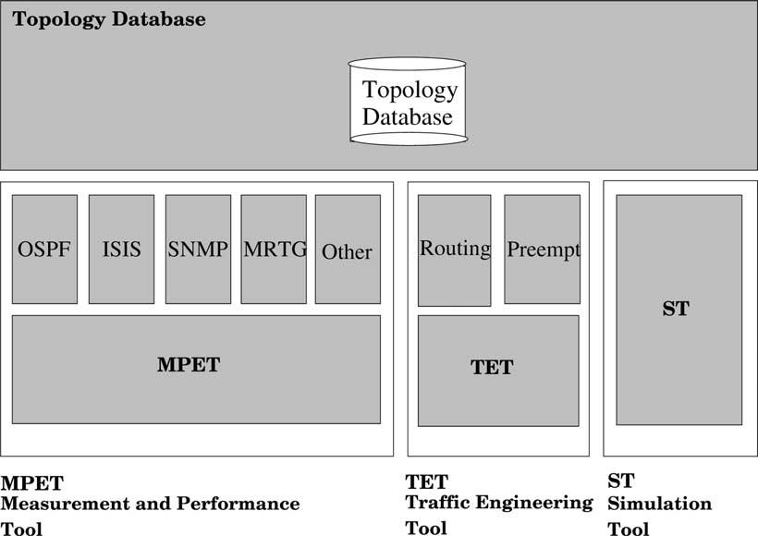
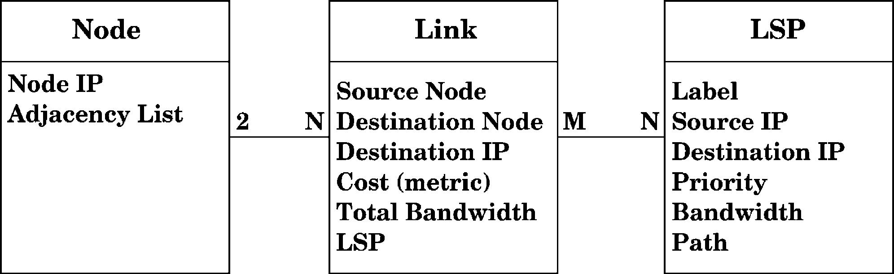
I.F. Akyildiz et al. / Computer Communications 26 (2003) 388–403

Fig. 5. Modules architecture.

401

to all management information and conﬁguration rights.
Preventive measurements such as packet ﬁltering and
conﬁguring agents to only accept packets whose source IP
address matches the manager can be used, but its
effectiveness is questionable since the packet can easily be
modiﬁed. SNMPv3 addresses this problem proposing a new
framework for the protocol. It enhances security incorpor-
ating authentication, encryption and integrity checks on
messages sent between the agent and the manager. Data
integrity is accomplished by adding an MD5 or SHA digest
to the message. It ensures that the message was not
tampered and that is coming from where it claims to be.
SNMPv3 also includes a timestamp on each message, so
that replay attacks cannot be used. Finally, it provides
support for data encryption between the agent and the
manager. The recommendation is to use DES, although the
speciﬁcation is open to other alternatives.
SNMPv3 also has the concept of custom tree views
for each user registered in the system. This way, we can
restrict access of a user to only a set of the MIB tree,
limiting the damage, in case the strings are compromised.
All commands between the manager and the routers are
carried over SNMPv3. Unfortunately, Cisco IOS only
exports read-only TE variables and tunnel setup cannot be
done using SNMP. We identiﬁed two options to work out
this limitation. The ﬁrst one it to use telnet to connect to the
router and send the CLI commands to create the MPLS

Fig. 6. Database structure.

tunnel. The second approach is to use SNMP and instruct
the router to retrieve the conﬁguration from a TFTP server
to create the new tunnel.
In our implementation, we adopted the second approach
since telnet is not secure and passwords are sent in clear
text. Adopting SNMPv3 as the management protocol, we
make sure passwords and commands are secured. Although
the new conﬁguration comes from the TFTP server in clear
text, it does not contain any sensitive information. These
commands are only relevant to the new tunnel setup and the
router merges it to the current conﬁguration.

7.2. TEAM architecture

The general architecture for TEAM is shown in Fig. 5.
Since all modules (TET, MPET and ST) need access to the
network topology, there is a centralized database and
speciﬁc functions to read and manipulate its content. MPET
is the module responsible to learn the topology of the
network and evaluate its current conditions. It is structured
in different modules and the main program executes each
one on a separate thread. This enables us to interpret
different information to build the topology map. For
example, link state routing protocols like OSPF and ISIS
require that every router in the area maintain a topology
database of the area they belong. One of the modules would
be responsible for listening to messages exchanged and
updating the topology database. SNMP can also be used to
retrieve routing information from the routers to update the
database. A separate set of thread will be responsible for
retrieving current bandwidth utilization, like MRTG.
Once the topology database is in place, the Trafﬁc
Engineering Tool (TET) is responsible for routing and
resources management and the Simulation Tool (ST) is
responsible for checking and validating TET decisions.

402

I.F. Akyildiz et al. / Computer Communications 26 (2003) 388–403

They will also access the topology database through the
same set of common functions.
TEAM keeps a database with the network topology and
connected LSPs in the domain. The database is updated by
MPET, which adds and remove links as they become
available or not. It also retrieves bandwidth utilization
statistics similarly to MRTG and updates link records. In
addition to the topology database, TEAM also maintains
some information about the established LSPs under its
domain, e.g. the LSP path. The database model is shown in
Fig. 6.

8. Conclusions

We propose the design of a set of new algorithms to
provide QoS and better resource utilization in an MPLS
network and an integrated architecture, TEAM, as an MPLS
domain manager. The new algorithms concern resource
management and route management. All algorithms will be
developed and evaluated through simulation and exper-
iments individually on our physical testbed. Now, we are
focusing on their inter-working and the development of
TEAM as a whole. We have a full-ﬂedged physical testbed,
with Next Generation Internet routers, equipped with
DiffServ-capable routers and switches manufactured by
Cisco. The integration of the above mentioned algorithms
will result in a unique and powerful method for Internet
management.

Acknowledgement

This work was supported by NASA Goddard. The work
of J. C. de Oliveira was also supported in part by CAPES
(The Brazilian Ministery of Education Agency).

References

[1] D.O. Awduche, J. Malcom, J. Agogbua, M. O’Dell, J. McManus,
Requirements for Trafﬁc Engineering over MPLS, IETF RFC 2702,
September 1999, http://www.ietf.org/rfc/rfc2702.
[2] D.O. Awduche, L. Berger, D. Gan, T. Li, V. Srinivasan, G. Swallow,
RSVP-TE: Extensions to RSVP for LSP Tunnels, IETF RFC 3209,
December 2001, http://www.ietf.org/rfc/rfc3209.
[3] D. Awduche, A. Chiu, A, Elwalid, I. Widjaja, X. Xiao, Overview and
Principles of Internet Trafﬁc Engineering, IETF RFC 3272, May
2002, http://www.ietf.org/rfc/rfc3272.
[4] R. Callon, Predictions for the core of the network, IEEE Internet
Computing 4 (1) (2000).
[5] J. de Oliveria, T. Anjali, B. King, C. Scoglio, Building an IP
Differentiated Services Testbed, Proceedings of IEEE International
Conference on Telecommunications, Bucharest, Romania, June,
2001.
[6] C. Scoglio, T. Anjali, J. de Oliveira, I.F. Akyildiz, G. Uhi, A New
Threshold-Based Policy for Label Switched Path Setup in MPLS
Networks, Proceedings of 17th International Teletrafﬁc Congress’01,
Salvador, Brazil, September, 2001.

[7] T. Anjali, C. Scoglio, J. de Oliveira, I.F. Akyildiz, G. Uhi, Optimal
policy for LSP setup in MPLS networks, Computer Networks 39
(2002) 2.
[8] J. de Oliveira, C. Scoglio, I.F. Akyildiz, G. Uhi, A New Preemption
Policy for DiffServ-Aware Trafﬁc Engineering to Minimize Rerout-
ing, Proceedings of IEEE INFOCOM’02, New York, USA, 2002.
[9] T. Anjali, C. Scoglio, I.F. Akyildiz, G. Uhi, A New Scheme for Trafﬁc
Estimation and Resource Allocation for Bandwidth Brokers, BWN
Lab Technical Report BWN-02-J-32.
[10] J. de Oliveira, F. Martinelli, C. Scoglio, SPeCRA: a Stochastic
Performance Comparison Routing Algorithm for LSP Setup in MPLS
Networks, Proceedings of IEEE GLOBECOM’02, Taipei, Taiwan,
November 2002.
[11] T. Anjali, C. Scoglio, L. Chen, I.F. Akyildiz, G. Uhl, ABEst: an
Available Bandwidth Estimator within an Autonomous System,
Proceedings of IEEE GLOBECOM’02, Taipei, Taiwan, November
2002.
[12] P. Aukia, M. Kodialam, P.V.N. Koppol, T.V. Lakshman, H. Sarin, B.
Suter, RATES: a server for MPLS trafﬁc engineering, IEEE Network
March/April (2000) 14.
[13] S. Herzog, J. Boyle, R. Cohen, D. Durham, R. Rajan, A. Sastry, COPS
usage for RSVP, IETF RFC 2749, January 2000, http://www.ietf.org/
rfc/rfc2749.
[14] K. Kar, M. Kodialam, T.V. Lakshman, Minimum interference routing
of bandwidth guaranteed tunnels with MPLS trafﬁc engineering
application, IEEE Journal on Selected Areas in Communications 18
(12) (2000) 2566 – 2579.
[15] A. Elwalid, J. Ching, S. Low, I. Widjaja, MATE: MPLS Adaptive
Trafﬁc Engineering, Proceedings of IEEE INFOCOM’01, Anchorage,
USA, April, 2001.
[16] P. Trimintzios, L. Georgiadis, G. Pavlou, D. Grifﬁn, C.F. Cavalcanti,
P. Georgatsos, C. Jacquenet, Engineering the Multi-Service Internet:
MPLS and IP-Based Techniques, Proceedings of IEEE International
Conference on Telecommunications, Bucharest, Romania, June,
2001.
[17] X. Xiao, A. Hannan, B. Bailey, L.M. Ni, Trafﬁc engineering with
MPLS in the Internet, IEEE Network Magazine March (2000).
[18] S. Uhlig, O. Bonaventure, On the Cost of Using MPLS for
Interdomain Trafﬁc, Proceedings of Quality of Future Internet
Services’00, Berlin, Germany, September, 2000, pp. 141 – 152.
[19] I.T. Okumus, J. Hwang, H.A. Mantar, S.J. Chapin, Inter-Domain LSP
Setup Using Bandwidth Management Points, Proceedings of IEEE
GLOBECOM’01, San Antonio, USA, November, 2001.
[20] Q. Hao, S. Tartarelli, M. Devetsikiotis, Self-Sizing and Optimization
of High-Speed Multiservice Networks, Proceedings of IEEE GLO-
BECOM’00, San Francisco, USA, November, 2000.
[21] J. Liebehetrr, S.D. Patek, E. Yilmaz, Trade-offs in Designing
Networks with End-to-end Statistical QoS Guarantees, Eighth
International Workshop on Quality of Service, 2000.
[22] M.L. Puterman, Markov Decision Processes: Discrete Stochaftic
Dynamic Programming, Wiley, New York, 1994.
[23] S. Poretsky, Connection Precedence and Preemption in Military
Asynchronous Transfer Mode (ATM) Networks, Proceedings of
MILCOM’98, 1998, pp. 86 – 90.
[24] S. Poretsky, T. Gannon, An Algorithm for Connection Precedence and
Preemption in Asynchronous Transfer Mode (ATM) Networks,
Proceedings of IEEE ICC’98, 1998, pp. 299 – 303.
[25] M. Peyravian, A.D. Kshemkalyani, Decentralized network connection
preemption algorithms, Computer Networks and ISDN Systems 30
(11) (1998) 1029 – 1043.
[26] J.A. Garay, I.S. Gopal, Call Preemption in Communication Networks,
Proceedings of IEEE INFOCOM’92, 1992, pp. 1043 – 1050.
[27] G. Armitage, Quality of Service in IP Networks, Macmillan Technical
Publishing, 2000, Technology Series.
[28] J.W. Roberts, Trafﬁc theory the Internet, IEEE Communications
Magazine 39 (1) (2001) 94 – 99.

I.F. Akyildiz et al. / Computer Communications 26 (2003) 388–403

403

[29] W.C. Feng, F. Jahaniam, S. Sechrest, An optimal bandwidth
allocation strategy for the delivery of compressed prerecorded
video, ACM/Springer Verlag Multimedia Systems Journal 5 (5)
(1997).
[30] A. Adas, Supporting Real-time VBR Video Using Dynamic
Reservation Based on Linear Prediction, Proceedings of IEEE
INFOCOM’96, San Francisco, USA, 1996, pp. 1476 – 1483.
[31] H. Zhang, E.W. Knightly, RED-VBR: a renegotiation based approach
to support delay sensitive VBR video, Multimedia Systems 5 (1997)
164 – 176.
[32] D. Reininger, G. Ramamurthy, D. Raychaudhuri, VBR MPEG video
coding with dynamic bandwidth renegotiation, IEEE International
Conference on Communications, Seattle, USA, June, 1995, pp. 1773 –
1777.
[33] K. Nichols, V. Jacobson, L. Zhang, A Two-bit Differentiated Services
Architecture for the Internet, IETF RFC 2638, July 1999, http://www.
ietf.org/rfc/rfc2638.
[34] White Paper, Cisco MPLS AutoBandwidth Allocator for MPLS
Trafﬁc Engineering, June 2001, http://www.cisco.com/warp/public/
cc/pd/iosw/prodlit/mpatb_wp.htm.
[35] A. Terzis, L. Wang, J. Ogawa, L. Zhang, Two-Tier Resource
Management Model for the Internet, Proceedings of IEEE GLOBE-
COM’99, December, 1999, pp. 1779 – 1791.
[36] Z. Zhang, Z. Duan, L. Gao, Y.T. Hou, Decoupling QoS Control from
Core Routers: a Novel Bandwidth Broker Architecture for Scalable
Support of Guaranteed Services, Proceedings of ACM SZGCOM’00,
Sweden, August, 2000.
[37] QBone Bandwidth Broker Advisory Council, http://www.internet2.
edu/qos/qbone/QBBAC.shtml.
[38] P.S. Maybeck, Stochastic Models, Estimation, and Control, Academic
Press, New York, 1979.
[39] S. Keshav, A Control-Theoretic Approach to Flow Control, Proceed-
ings of ACM SZGCOM’91, Zurich, Switzerland, 1991.
[40] A. Kolarov, A. Atai, J. Hui, Application of Kalman Filter in High-
Speed Networks, Proceedings of IEEE GLOBECOM’94, San
Francisco, USA, 1994, pp. 624 – 628.
[41] L. Kleinrock, Queueing Systems, Wiley, New York, 1975.
[42] E. Rosen, A. Viswanathan, R. Callon, Multiprotocol Label Switching
Architecture, IETF RFC 3031, January 2001, http://www.ietf.org/rfc/
rfc3031.
[43] J. Moy, OSPF Version 2, IETF RFC 2328, April 1998, http://www.
ietf.org/rfc/rfc2328.

[44] R. Callon, Use of IS-IS for Routing in TCP/IP and Dual
Environments, IETF RFC 1195, December 1990, http://www.ietf.
org/rfc/rfc1195.
[45] R. Guerin, A. Orda, D. Williams, QoS Routing Mechanisms and
OSPF Extensions, Proceedings of Second Global Internet Minicon-
ference (Joint with GLOBECOM’97), Phoenix, USA, November,
1997.
[46] Z. Wang, J. Crowcroft, Quality-of-service routing for supporting
multimedia applications, IEEE Journal on Selected Areas in
Communications 14 (7) (1996) 1234 – 1288.
[47] D. Eppstein, Finding the k shortest paths, SIAM Journal of Computing
28 (2) (1998) 652 – 673.
[48] G. Apostolopoulos, R. Guerin, S. Kamat, S.K. Tripathi, Quality of
Service Based Routing: a Performance Perspective, Proceedings of
SIGCOMM’98, 1998.
[49] L. Dai, C.H. Chen, Rates convergence of ordinal comparison for
dependent discrete event dynamic systems, Journal of Optimization
Theory and Applications 94 (1) (1997) 29 – 54.
[50] K. Lai, M. Baker, Measuring Bandwidth, Proceedings of IEEE
INFOCOM’99, New York, USA, March, 1999.
[51] V. Jacobson, Pathchar, 1997, ftp://ftp.ee.lbl.gov/pathchar/.
[52] K. Lai, M. Baker, Nettimer: a Tool for Measuring Bottleneck Link
Bandwidth, Proceedings of Third USENIX Symposium on Internet
Technologies and Systems, San Francisco, USA, March, 2001.
[53] R.L. Carter, M.E. Crovella, Measuring Bottleneck Link Speeds in
Packet-Switched Networks, Boston University Technical Report BU-
CS-96-006, 1996.
[54] V. Paxson, End-to-end Internet Packet Dynamics, Proceedings of
ACM SIGCOMM’97, Cannes, France, September, 1997.
[55] M. Jain, C. Dovrolis, Pathload: a Measurement Tool for End-to-End
Available Bandwidth, A Workshop on Passive and Active Measure-
ments, Fort Collins, USA, March, 2002.
[56] Iperf Tool, http://dast.nlanr.net/Projects/Iperf.
[57] Cisco IOS Netﬂow Website, http://www.cisco.com/warp/public/732/
Tech/netﬂow/.
[58] J. Case, K. McCloghrie, M. Rose, S. Waldbusser, Introduction to
version 2 of the Internet-standard Network Management Framework,
IETF RFC 1441, 1993, http://www.ietf.org/rfc/rfcl441.
[59] MRTG Website, http://people.ee.ethz.ch/oetiker/webtools/mrtg/.
[60] RRDTool Website, http://people.ee.ethz.ch/oetiker/webtools/rrdtool/.
[61] M.H. Hayes, Statistical Digital Signal Processing and Modeling,
Wiley, New York, 1996.

